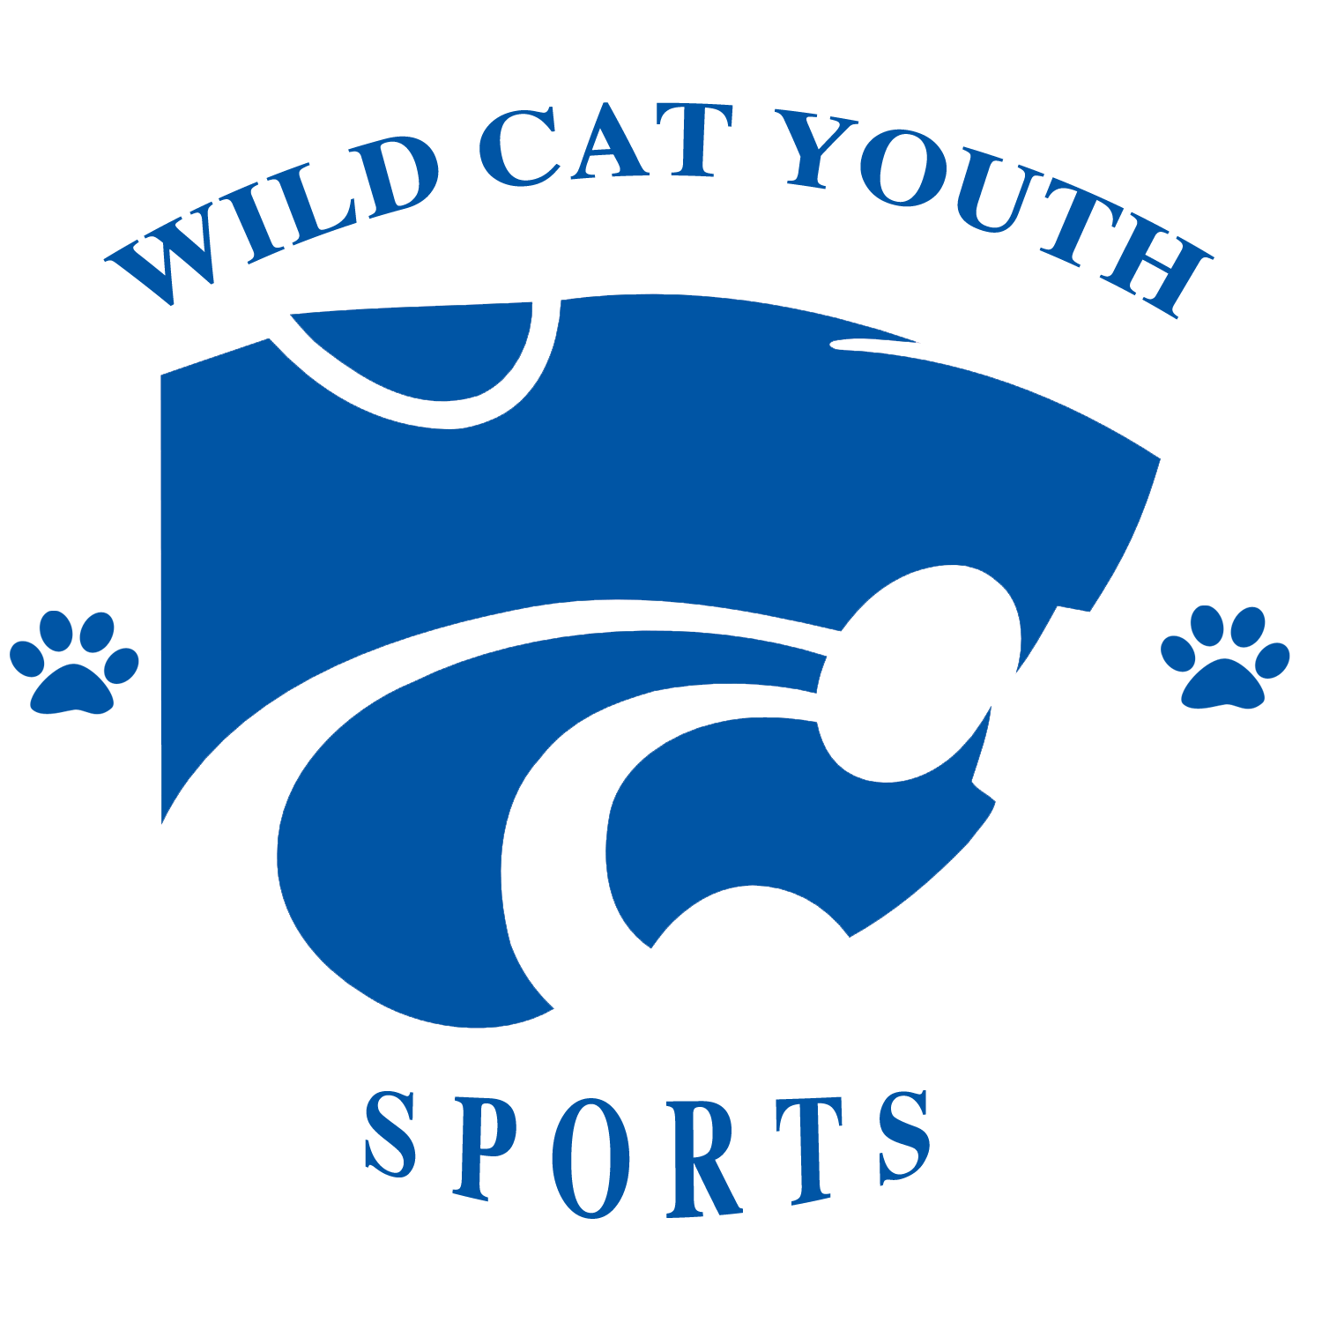

WILDCAT YOUTH SPORTS 2023 Track & field Application

Applicant Information
Student Name: |  | Date of birth: |  | Returner:
Student Name: |  | Date of birth: |  | Returner:
Student Name: |  | Date of birth: |  | Returner:

parent Information
Mother Name: Father Name:
Current address:
Home Phone: | E-mail:
Cell: Cell: | Email2:

Emergency Contact
Name: Relationship:
Home Phone: Cell:

Medical Information
Child Known Allergies:
Doctor Name: | Phone Number: |  | Hospital:

Waiver Information
This waiver of liability is executed in regard to my child or children’s participation in activity involving Wildcat Youth Sports Organization. I understand that my child or children are not required to participate in the activities.
I understand there are certain physical risks created by participating in sporting activities. I will not hold the Wildcat Youth Sports Organization “Responsible” for any injuries, which may occur, as a result of my child or children’s participation. My child or children has no physical limitations, which will prevent him/her from participating.
I acknowledge that we have read the foregoing WAIVER OF LIABILITY, we understand it completely, and agree not to hold Wildcat Youth Sports Organization, responsible for any injuries that may result from my child or children’s participation.

Signatures
I authorize the above information provided on this form is true and correct.
Parent/Guardian Signature: |  |  | Date:

Age Groups |  | 5-8  years |  | 9-10  years |  | 11-12 years |  | 13-14 15-18  years  years

PLEASE HAVE A COPY OF CHILD’S BIRTH CERTIFICATE W/COMPLETED APPLICATION
THERE ARE NO REFUNDS UNDER ANY CIRCUMSTANCES
( Mandatory Fundraiser For Every Sports)
24 Hour Hotline # 972-480-5278

Mail completed application/checks to: Wildcat Youth Sports Organization
P.O. Box 700152
Dallas, TX 75370

WWW.WILDCATYOUTHSPORTS.ORG

